<$ScrKeepWithNext><$Scr_H::2><$Scr_Ps::0>What Happens When Events Arrive?
<!$Scr_H::2><!$Scr_Ps::0>
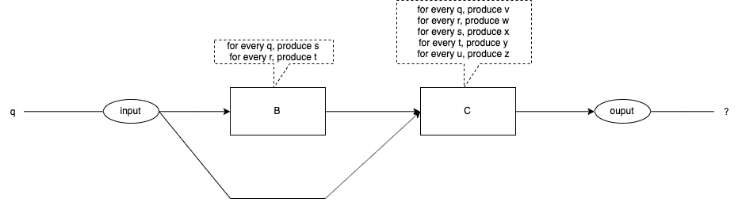
Fig. <$n:figure:SyncVsAsync-WhatHappens> An Event Arrives

What happens when an event arrives at the input? See Fig. <$n:figure:SyncVsAsync-WhatHappens>.

The event, "q", is injected into the input.

The algorithms specify exactly what each box does for any given input.

What is the expected output?

Do we see the expected output every time?

Do we see the expected output for every coding of the diagram?

